The following pictures are to be domesticated AS ILLUSTRATIONS

Figure 1: Relation of module to programme
The diagram should be common across ALL modules. However, the individual module focus should be highlighted in each case.

Figure 2: A magazine

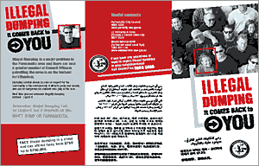

Ideally, replace this image with a copy of a magazine article discussion the problem of pollution in Nigeria.
Fig 3a A Model (3D) Fig 3b A Model

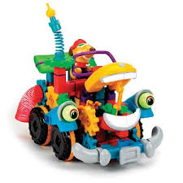
Fig 4 A combination of 2D & 3D shapes

Page 13
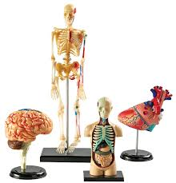
Fig 5 A 3D models
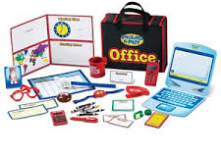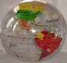
Fig 5b A model (combination of 2D & 3D) Fig 5c 3D (Globe)

Fig 6 A model (combination of 2D & 3D)
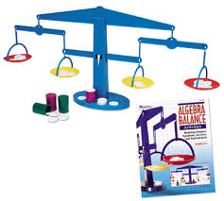
Fig 7 3D objects

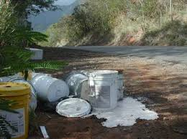
Fig 8 3D (Books) Fig 9 2D picture

The source of the above clipart is not known. The exact examples are not important provided there is a range of different resources illustrated. Note that the 9 separate figures could be clustered into a single full page or double-spread page illustration (as Figure 3: Resources found in the dumpsite with educational potential).

Hand-out A
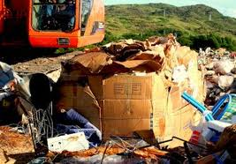
ENVIRONMENTAL, HEALTH, AND ECONOMIC EFFECTS OF ILLEGAL DUMPING
Illegal dumping can disrupt natural processes on land and in the water. Dumping can interfere with proper drainage of runoff. Areas are more susceptible to flooding when waste blocks ravines, creeks, culverts, and drainage basins. In rural areas, burning at dump sites can cause forest fires and severe erosion as fires burn away trees and undergrowth. The run-off from improper disposal of toxic substances such as motor oil or household cleansers can contaminate lakes, streams, and drinking water supplies.
Dumping also has a negative impact on plants and wildlife. Many birds and small animals die after ingesting or becoming entangled in debris. Fish and other aquatic species are killed when decomposing litter and food wastes in streams deplete oxygen supplies in the water. Refuse in a stream can also clog fish spawning areas.
Dumped appliances are not only an eyesore, but can also release toxic chemicals. Refrigerators and freezers may release chlorofluorocarbon (CFC) into the air, harming the earth’s protective ozone layer. Improperly discarded appliances built before 1979 may also leak polychlorinated biphenyls (PCBs) into the soil. According to the EPA, PCBs can cause cancer, reproductive failure and hormone imbalances in animals and humans.
Health. Appliances are a special danger for small children. Older refrigerators and freezers may look like fun forts or houses to kids, but they can easily become trapped inside. Other physical hazards to both children and adults include the risk of cuts and infections from protruding nails and sharp edges. There may also be less noticeable chemical hazards from toxic fluids or dust. Sites which include scrap tires are ideal breeding grounds for mosquitoes. The insects can breed 100 times faster than normal in the warm, stagnant water which collects inside the tires. Some of the mosquitoes can carry life- threatening diseases such as Dengue Fever, Yellow Fever, and Encephalitis. Other insects, rodents, and additional animals attracted to dumps may also pose health risks.
As mentioned previously, illegal dumps are also frequent sites for fire, either by spontaneous combustion or arson. The fires are extremely dangerous for those living in the area and especially for the fire fighters responsible for putting out the flames. Dumps can contain old aerosol cans or gas cans which can explode. Discarded chemicals from households and farms can also give off toxic smoke.
Economic. The presence of illegal dumps results in a decrease of neighborhood property values. The community as a whole also becomes unattractive to prospective commercial and residential developers. The loss of commercial development is especially damaging in poor counties where the unemployment rate is high and new employment opportunities are desperately needed. Also, without the tax revenues that accompany development, the funding available to establish and maintain effective illegal dumping prevention programs is limited.
The costs faced by local governments to continually clean up illegal dump sites are significant. Some areas have spent up to several million dollars each year for clean up, hauling, and disposal activities. The expense can then be passed to residents in the form of higher service fees or property taxes.

The source of this handout is not known. It might be useful anyway to reset it to look more like a flyer/magazine article.

Page 23
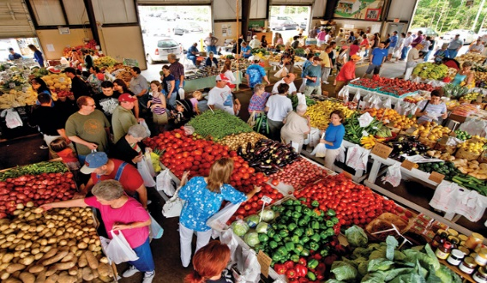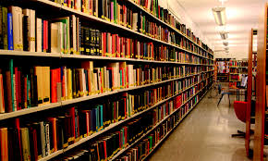
Fig 1 A Market Fig 2 A Library

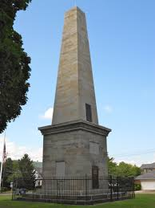
Fig 4 A Monument

Fig 5 A Museum Fig 6 A Zoo
Fig 7 A Gallery

Fig 8 A Television
At least some of the above graphics should be replaced with recognizable Nigerian equivalents. They need not be featured as separate diagrams. As previously, they might be clustered on a single page or a spread with a single title e.g. Figure 4: Examples of community resources.

The following graphics currently on pp27+ should also ideally be replaced with high resolution pictures appropriate to the Nigerian context.

Page 27

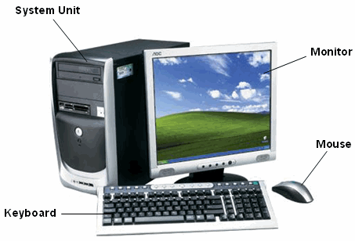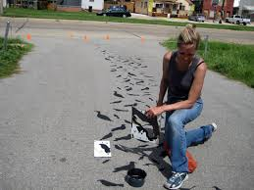
Fig 10 Computer System Fig 11 Field Work Guide

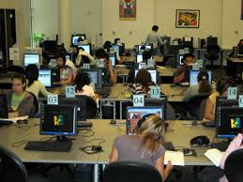
Fig 12 Open LearningMaterials Fig 13 Open Learning Materials
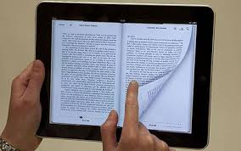
Fig 14 E-books Fig 15 E-learning

Page 28
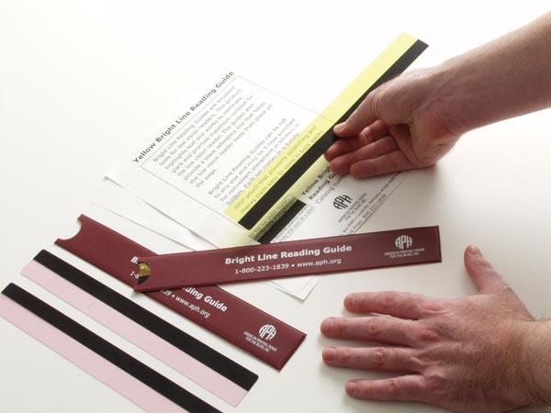

Fig 18 Project Guide Fig 19 Reading Set

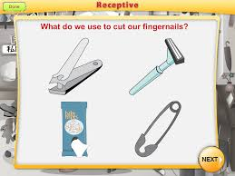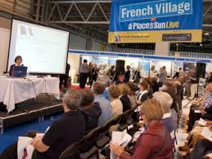

Fig 20 Real Object Fig 21 Seminar Guide
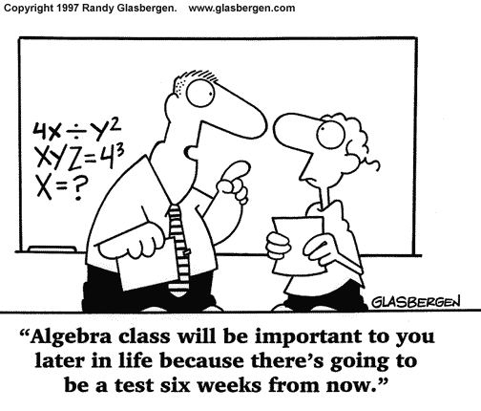
Fig 23 Study Guide

Page 29
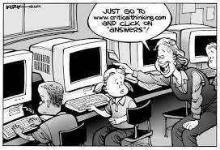

Fig 24 Skills Profile Fig 25 Skills Guide
Fig 26 Specimens Fig 27 Work placement Guide

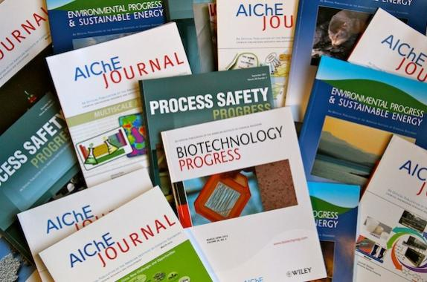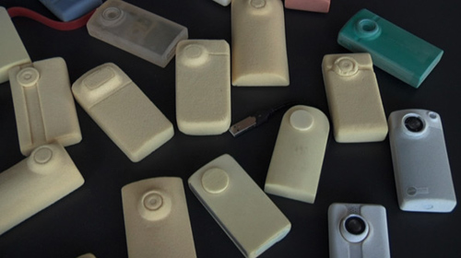
Fig 28 Logs Fig 29 Models
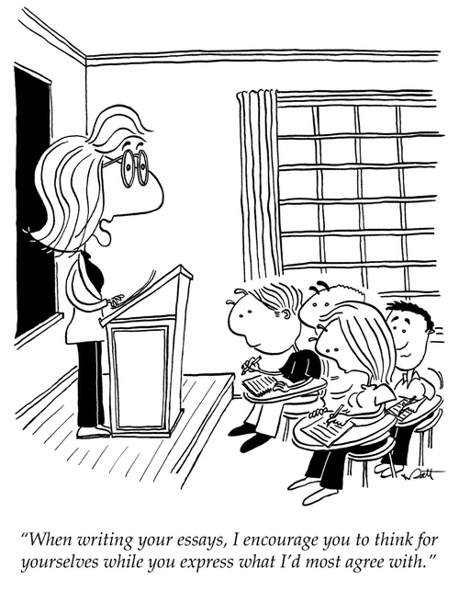
Fig 30 Skills guide

Page 30

Fig 31 Learning pack
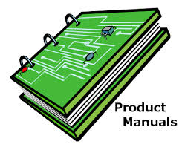
Fig 32 Staff and Students Guide

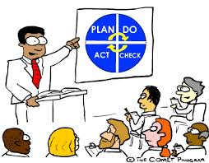
Fig 33 Staff and Students instructional Guide

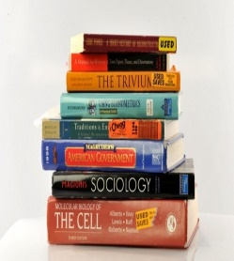
Fig 35 Text Books Fig 36 Dancing

The following graphics from Section 3.2, p37+ need to be replaced with clearer examples (the white text on brown background will not reproduce well in print) as well as with photos more appropriate for the Nigerian context.
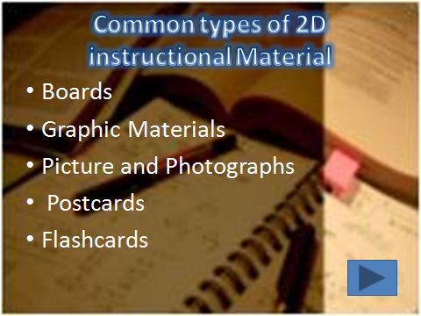
Fig 1 Types of 2D resources

3.2.1 Types of Boards
Fig 2 Types of borads
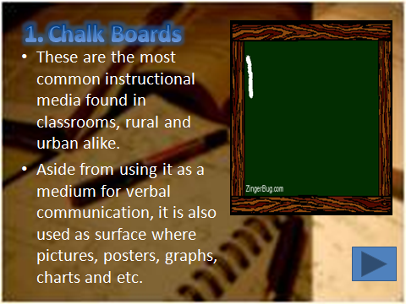
Fig 3 Chalk boards
e
a
a
a

Fig 4 Chalk boards

Fig 5 White and Magnetic boards
Fig 6 Advantages and limitations of magnetic boards

Fig 7 Cloth boards
Fig 8 Examples of Cloth boards

Fig 9 Hook and loop boards
Fig 10a Bulletin boards
Fig 10b Bulletin boards

3.2.2 Types of Graphic LR
Fig 11 Graphic materials
Fig 12 Types of graphic materials

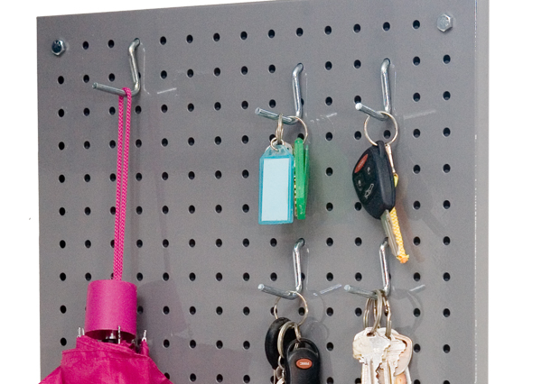

Fig 12 Fixed boards

The following illustration from Activity 3b, p47.as well as the related illustrations on p48 need to be replaced by high res Nigerian examples …
Fig 12 Line Graphs

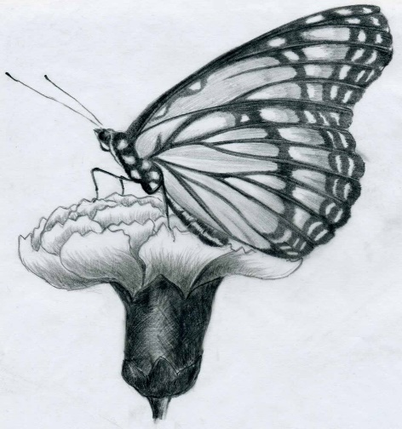
Fig 13 2-D Drawings Fig 14 3-D drawings

The following images from Unit 4, pp48-49, need to be replaced with high res OER images.
Fig 1 Objects and specimens

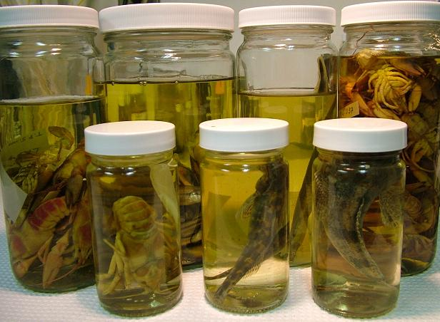
Fig 2b specimens
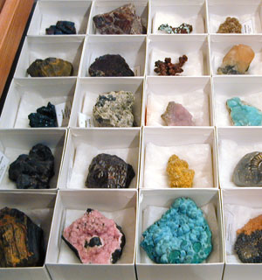
Fig 2c Specimens Fig 2d Specimens

This diagram from 4.3, p. 52 could usefully be replaced by higher resolution images and perhaps with some Nigerian artefacts in the 2nd table.
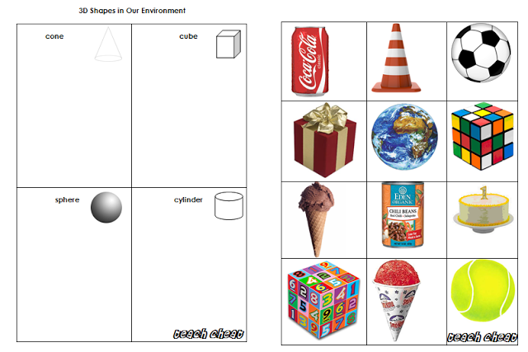
Fig 3 Solid shapes

